**FRIO COUNTY COMMISSIONERS COURT MINUTES FOR**

**Regular Meeting December 13, 2022**

On the 13th day of December, 2022, at 3:00 p.m., the Commissioners Court of Frio County met in a regular

meeting with the following members either absent or present, to-wit: Arnulfo C. Luna, Frio County Judge was present; Joe Vela, Commissioner Pct 1 present; Richard “Dicki” Graf, Commissioner Pct 2 absent; Raul Carrizales, Commissioner Pct 3 present; Jose Asuncion, Commissioner Pct 4 present; Joseph A. Sindon, Legal Counsel for Frio County Commissioners Court present; and Aaron Ibarra, Frio County Clerk present when the following meeting was held, to-wit:

I. Invocation and Pledge of Allegiance

II. Adopt Agenda

III. Old Business

**PRESENTATION**

**ACTION AGENDA ITEMS**

(1) Hon. Crystal Marquez, Frio County Auditor, requests:

Discuss / take action on refunding Mary Moore for uncompleted requested voter data information for a total amount of $1,649.00, and determine which budget to issue the refund.

MOTION: RAUL CARRIZALES

SECOND: JOSE ASUNCION

MOTION PASSED

IV. General Discussion

V. Citizens To Be Heard

*Please note that the Rules of Procedure, Conduct and Decorum at Meetings of the Commissioners Court of Frio County, Texas limit each speaker to a maximum of three (3) minutes to make his or her remarks. Inappropriate conduct or comments during this time, including but not limited to disruptive behavior, insults, personal attacks, and inappropriate language, may result in the speaker being ordered to leave the meeting and forfeit any remaining speaking time. For more information regarding the above-mentioned rules, please see the complete Rules of Procedure, Conduct and Decorum at Meetings of the Commissioners Court of Frio County, Texas, which is available upon request.*

NONE

VI. New Business

**PRESENTATION**

(1) Ronald Rocha, Attorney at Law, Linebarger Goggan Blair & Sampson, LLP**,** requests:

Update on the delinquent fines and collection services by Linebarger Goggan Blair & Sampson LLP.

**ACTION AGENDA ITEMS**

(1) Robert Carter, Leal and Carter, P.C., requests:

1.1 Present Frio County audited financial statements for fiscal year 2020-2021.

1.2 Accept and approve audited financial statements for fiscal year 2020-2021.

MOTION: RAUL CARRIZALES

SECOND: JOSE ASUNCION

MOTION: PASSED

(2) Ruben J. Saldana, Ed.D., Texas A&M Agrilife Extension District Extension Administrator, requests:

Consider/take action on approving the hiring of the recommended candidate, Sarah Nicholson, for the Frio County Extension Agent – Family and Community Health position.

MOTION: RAUL CARRIZALES

SECOND: JOSE ASUNCION

MOTION: PASSED

(3) Selena Martinez, Dilley High School Class of 2012. Requests:

Extend time to use Frio County Regional Park on March 25, 2023 until 12:00 a.m.

TABEL FOR NOW

(4) Hon. Daniel Zapata, Frio County Constable, Precinct No. 3, requests:

4.1 Consider/take action on designating the 2015 Ford Explorer VIN #1FM5K788FGC06877 as salvage or surplus property.

4.2 Consider / take action on approving the sale of 2015 Ford Explorer VIN #1FM5K788FGC06877 to the Pearsall ISD Technology Department for the amount of $1.00.

MOTION: RAUL CARRIZALES

SECOND: JOSE VELA

MOTION: PASSED

(5) Hon. Anna L. Alaniz, Frio County Tax Assessor-Collector, requests:

5.1 Discuss/take action on renewing the Frio County Tax Office Computer System Lease/License Agreement by and between Pritchard & Abbott, Inc. and the Frio County Tax Office from January 1, 2023 to December 31, 2024 for a yearly cost of $39,100.00 for the first year and $41,400.00 for the second year.

5.2 If the above agreement is approved, consider/take action on signing a resolution authorizing Frio County Judge Arnulfo C. Luna to sign and enter into same on behalf of Frio County, Texas.

MOTION: JOSE ASUNCION

SECOND: RAUL CARRIZALES

MOTION: PASSED

(6) Hon. Mike Morse, Frio County Sheriff, requests:

Consider/take action on waiving the probationary period for being able to access Blue Cross Blue Shield of Texas Insurance Benefits for new employees Deputies Rodolfo Olazaba, Mathew Guerra, and Luis Maldonado.

MOTION: RAUL CARRIZALES

SECOND: JOSE ASUNCION

MOTION: PASSED

(7) Hon. Mike Morse, Frio County Sheriff, requests:

7.1 Consider / take action on approval of FCSO Earned Vacation sell back policy addendum to Frio County Policy Manual.

7.2 Consider / take action to approve pay out for policy eligible employees totaling $13,828.75.

MOTION TO APPROVE AS WRITTEN 7.1, 7.2. Going forward Sheriffs Office will work to ensure line items are created and appropriated.

MOTION: RAUL CARRIZALES

SECOND: ARNULFO LUNA

MOTION: PASSED

(8) Hon. Mike Morse, Frio County Sheriff, requests:

Consider / take action to approve reimbursement for ranch damages for the Allen Ranch for the amount of $454.96.

(9) Hon. Mike Morse, Frio County Sheriff, requests:

Consider / take action to allow the Frio County Sheriff’s Office to host the Sheriff’s Country Christmas at the Frio Fireman’s Park on December 16, 2022 from 6PM-9PM.

MOTION: RAUL CARRIZALES

SECOND: JOSE ASUNCION

MOTION: PASSED

(10) Hon. Crystal Marquez, Frio County Auditor, requests:

10.1 Consider / take action to approve the budget amendments to the FISCAL YEAR 2022-2023 Frio County Budget, list below:

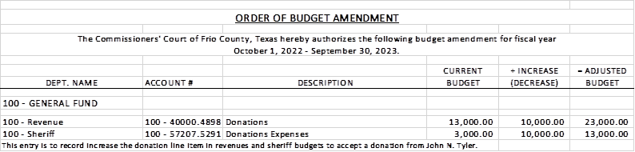

10.2 If the amendment is approved, consider/take action on signing order stating same.

MOTION: JOSE ASUNCION

SECOND: RAUL CARRIZALES

MOTION: PASSED

(11) Hon. Crystal Marquez, Frio County Auditor, requests:

11.1 Consider / take action to approve the budget amendments to the FISCAL YEAR 2022-2023 Frio County Budget, list below:

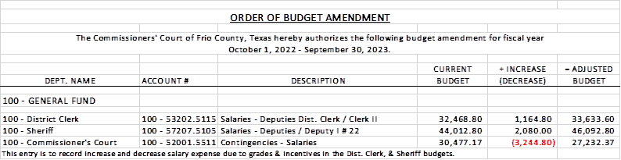

11.2 If the amendment is approved, consider/take action on signing order stating same.

MOTION: RAUL CARRIZALES

SECOND: JOSE ASUNCION

MOTION: PASSED

(12) Hon. Crystal Marquez, Frio County Auditor, requests:

12.1 Consider / take action to approve the budget amendments to the FISCAL YEAR 2022-2023 Frio County Budget, list below:

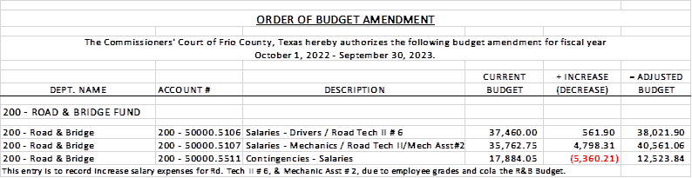

12.2 If the amendment is approved, consider/take action on signing order stating same.

MOTION: RAUL CARRIZALES

SECOND: JOSE ASUNCION

MOTION: PASSED

(13) Roxana Garcia, P.E., Frio County Engineer, requests:

Consider/take action on selecting an engineer from qualifications received by the specified deadline for an engineering firm registered in the State of Texas to provide Construction Engineering Inspection (CEI) services.

MOTION: JOSE ASUNCION

SECOND: JOSE ASUNCION

MOTION: PASSED

(14) Roxana Garcia, P.E., Frio County Engineer, requests:

14.1 Consider/take action on approving and adopting a resolution granting a permit for a $450.00 fee to Trinity Operating (USG), LLC, to lay, construct and maintain three (3) temporary twelve-inch (12”) water poly pipelines in CR 4670 right-of-way.

14.2 If the resolution is approved and adopted, then authorize Frio County Judge Arnulfo C. Luna to execute a Right of Way Agreement on behalf of Frio County, Texas to Trinity Operating (USG), LLC.

MOTION: RAUL CARRIZALES

SECOND: JOSE ASUNCION

MOTION: PASSED

(15) Roxana Garcia, P.E., Frio County Engineer, requests:

Discussion regarding the progress of construction for the Frio County Building Improvement Project located at 1796 IH 35E, Pearsall, Texas 78061.

(16) Roxana Garcia, P.E., Frio County Engineer, requests:

16.1 Consider/take action on approving Change Order #3 with Sandoval Contracting for the Frio County Building Improvement Project located at 1796 IH 35E, Pearsall, Texas 78061.

16.2 If the change order is approved, consider/take action on approving a resolution authorizing Hon. Arnulfo C. Luna, Frio County Judge, to enter into same on behalf of Frio County.

MOTION: RAUL CARRIZALES

SECOND: JOSE ASUNCION

MOTION: PASSED

(17) Hon. Aaron Ibarra, Frio County Clerk, requests:

17.1 Review Frio County Commissioners Court minutes for August 8, 9, 10, 11, 22, 30, 31, September 1, 12, 26, October 11, 25, and November 9, 2022.

17.2 Consider/Approve Frio County Commissioners Court minutes for August 8, 9, 10, 11, 22, 30, 31, September 1, 12, 26, October 11, 25, and November 9, 2022.

(18) Hon. Jose Asuncion, Frio County Commissioner, Precinct No. 4, requests:

Consider/take action on accepting the proposed schedule for Frio County Outreach and Enrollment Services provided by South Texas Rural Health Services.

MOTION: JOSE ASUNCION

SECOND: RAUL CARRIZALES

MOTION: PASSED

(19) Frio County Commissioners Court, requests:

19.1 Consider/take action on approving a ARPA Subrecipient Agreement between Frio County and the Frio County Junior Livestock Show, Inc. for use of County-granted ARPA funding.

MOTION: RAUL CARRIZALES

SECOND: JOE VELA

MOTION: PASSED

19.2 If the agreement is approved, then approve and sign a resolution authorizing Frio County Judge Arnulfo C. Luna to execute the contract on behalf of Frio County, Texas.

(20) Frio County Commissioners Court, requests:

Receive in person from the following county officials the following reports as mandated by law:

20.1 Presentation by Frio County Treasurer of detailed report as mandated by Section 114.026, Local Government (“Code”) (this report is to be presented at each **regular term of commissioners court).**

20.2 Frio County Treasurer to exhibit the books and accounts of that office for the inspection of the commissioners court (**to be done at each regular term of commissioners court).**

20.3 Consider/take action on authorizing the execution by Frio County Commissioners Court (the Judge and each commissioner) of an affidavit stating the requirements of the treasurer’s report have been met as mandated by section 114.026 of the Code.

MOTION: RAUL CARRIZALES

SECOND: JOSE ASUNCION

MOTION: PASSED

20.4 Consider/take action on execution of an order of the commissioners court approving the county treasurer’s report and order their publication in the Frio-Nueces Current as mandated by Section 114.026 of the Code or publication on the county’s website.

(21) Frio County Commissioners Court requests:

Presentation, pursuant to Section 114.044 of the Local Government Code, by:

1. Frio County District Clerk;

2. Frio County Clerk

3. Frio County Treasurer

4. Frio County Attorney

5. Frio County Judge

6. Frio County Sheriff

7. Frio County Auditor

8. Frio County Justice of the Peace

9. Frio County Constables

**(who collects or handles any money for the use of the county) of all fines imposed, judgments rendered and collected, and all jury fees collected by the respected courts in favor of or for the use of the county and at that time when the reports are presented to present receipts vouchers that show disposition of the money, fines or judgments.**

After examination by the commissioners court as to the correctness of the reports, consider/action on directing the county clerk to enter information in county finance records as mandated by Section 114.044 of the Code.

MOTION: RAUL CARRIZALES

SECOND: JOSE ASUNCION

MOTION: PASSED

(22) Documents (resolutions, orders, contracts, etc.) to be signed.

(23) Allow bills payable

(24) Adjourn

MOTION: RAUL CARRIZALES

SECOND: JOSE VELA

MOTION: PASSED